EXP NO:07 DATE:

DESIGN THE PCB LAYOUT OF A LOW NOISE AMPLIFIER USING KEYSIGHT ADVANCED DESIGN SYSTEM
AIM

To design the PCB layout of a Low Noise Amplifier (LNA) using Keysight Advanced Design System (ADS), perform layout verification, and analyze the RF performance through simulation.

SOFTWARE REQUIRED

- Keysight Advanced Design System (ADS)

COMPONENTS REQUIRED

S.No. | Component | Value/Specification
1 | Resistors | 100kΩ,33kΩ,10Ω
2 | capacitors | 0.8 pf,1.5pf,100pf
3 | inductors | 2.2nH,10nH,3.3nH
4 | BJT NPN Transistor | BFP420
5 | Buzzer | 5 V
6 | DC Supply | 3.3V

THEORY

A Low Noise Amplifier (LNA) is an RF amplifier used to amplify weak signals with minimum added noise. In this circuit, the BFP420 NPN transistor provides amplification, while the input and output matching networks provide proper 50 Ω impedance matching.The circuit operates with a 3.3 V supply. The R1–R2 network provides transistor biasing, while R3 and C2 provide emitter stabilization and RF bypassing. C1–L1 form the input matching network, and C3–L4 form the output matching network. L3 provides collector DC bias while isolating the RF signal from the supply.The RF performance is analyzed using S-parameters (S11, S21, S12 and S22). The PCB layout is verified using DRC and LVS, followed by Momentum EM simulation to evaluate the RF performance of the physical layout.
CIRCUIT DESIGN
1. Transistor Selection
- Select BFP420 NPN transistor from the ADS component library.
- Use the transistor as the RF amplification device.
2. Biasing Circuit
- Connect R1 = 100 kΩ and R2 = 33 kΩ for transistor biasing.
- Apply VDD = 3.3 V.
3. Input Matching
- Connect C1 = 1.5 pF and L1 = 2.2 nH at the RF input.
- Use P1 = 50 Ω as the input port.
4. Emitter Circuit
- Connect R3 = 10 Ω at the emitter.
- Connect C2 = 100 pF for RF bypassing.
5. Output Matching
- Connect L3 = 10 nH at the collector for RF/DC isolation.
- Connect C3 = 0.8 pF and L4 = 3.3 nH at the output.
- Use P2 = 50 Ω as the output port.
6. Simulation
- Add the S-parameter simulation controller.
- Simulate the circuit over the required frequency range.
- Observe S11, S21, S12 and S22.
CIRCUIT PRINCIPLE
1. RF Amplification
- The BFP420 NPN transistor amplifies the weak RF input signal while maintaining low noise.
2. Biasing
- The R1–R2 network establishes the required DC operating point of the transistor using a 3.3 V supply.
3. Input Matching
- The C1–L1 network provides impedance matching between the 50 Ω RF source and the transistor input.
4. Output Matching
- The C3–L4 network matches the transistor output to the 50 Ω load for efficient RF power transfer.
5. RF Isolation
- L3 provides DC bias to the collector while isolating the RF signal from the DC supply.
6. Performance Analysis
- The LNA performance is evaluated using S11, S21, S12 and S22 through ADS simulation.
CIRCUIT DIAGRAM
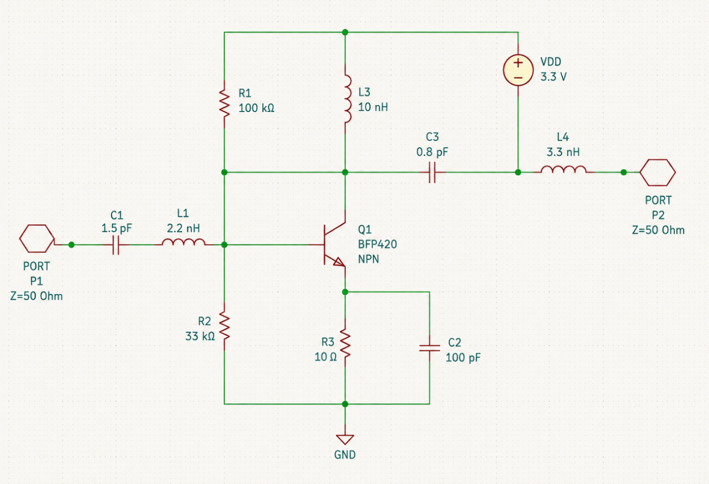

WAVEFORMS:

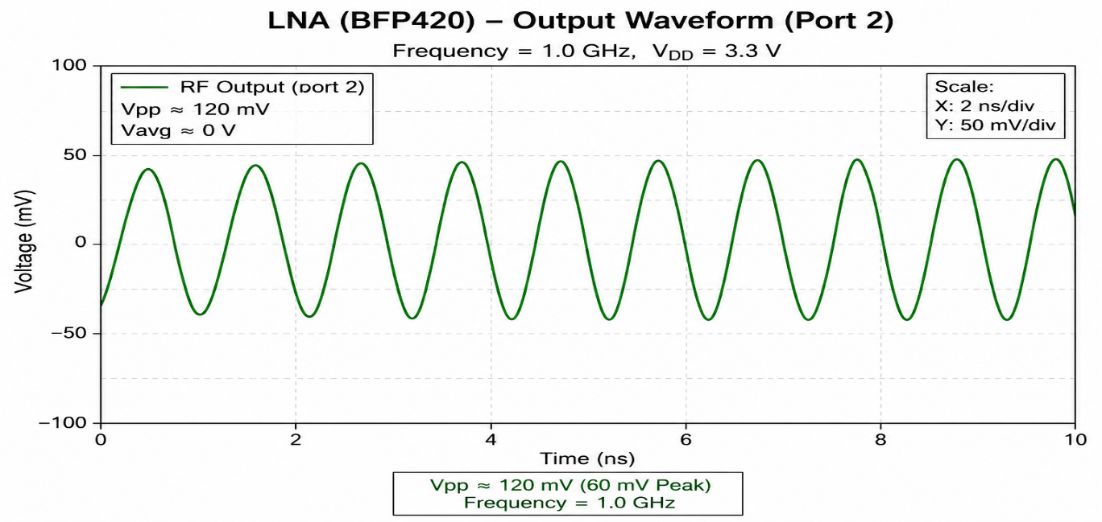
PROCEDURE
1.Open ADS and create a new workspace.
2.Draw the schematic as shown in the circuit diagram using ADS components.
3.Select the BFP420 transistor and place all passive components.
4. Set the supply voltage: VDD​=3.3V using the DC Voltage Source and connect it properly.
5. Add the S-parameter simulation controller.
6. Simulate the circuit and verify that the circuit provides gain in the required frequency band.

RESULT

The PCB layout of the Low Noise Amplifier was successfully designed in Keysight ADS. Layout verification (DRC and LVS) was performed, and the RF performance was analysed using S-parameter simulation.

